Database – Music Store Data Analysis using SQL
Music Playlist Database Schema :
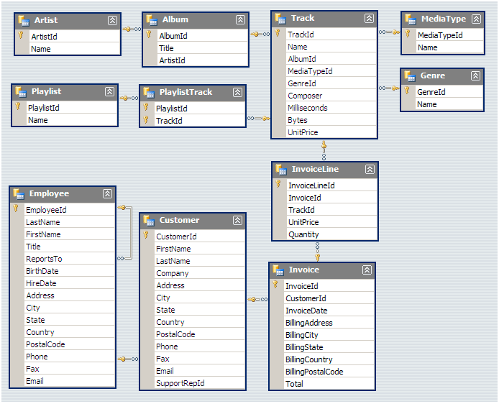
Queries :
- Who is the senior most employee based on job title?


Output :

- Which countries have the most Invoices?
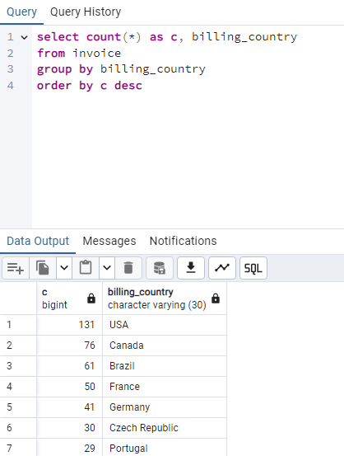
- What are top 3 values of total invoice?
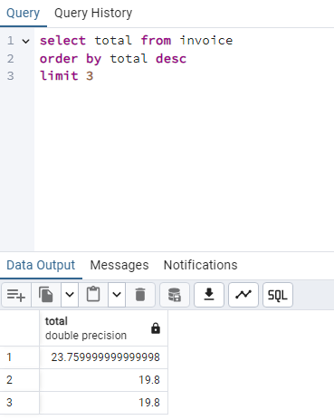

- Which city has the best customers? We would like to throw a promotional Music Festival in the city we made the most money. Write a query that returns one city that has the highest sum of invoice totals. Return both the city name & sum of all invoice totals
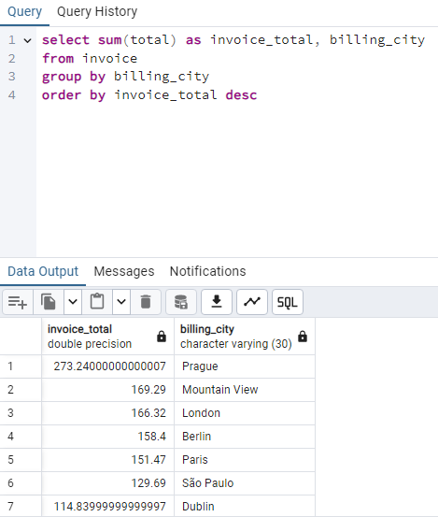

- Who is the best customer? The customer who has spent the most money will be declared the best customer. Write a query that returns the person who has spent the most money
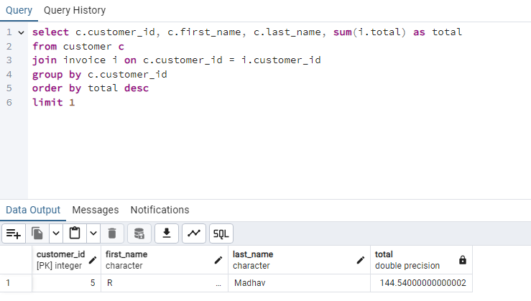
- Write query to return the email, first name, last name, & Genre of all Rock Music listeners. Return your list ordered alphabetically by email starting with A
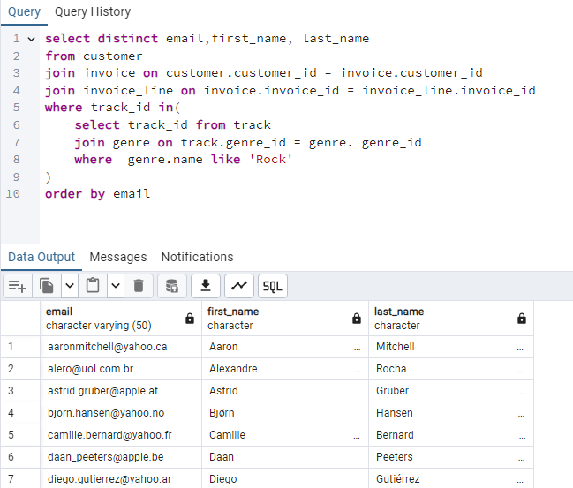
- Let's invite the artists who have written the most rock music in our dataset. Write a query that returns the Artist name and total track count of the top 10 rock bands
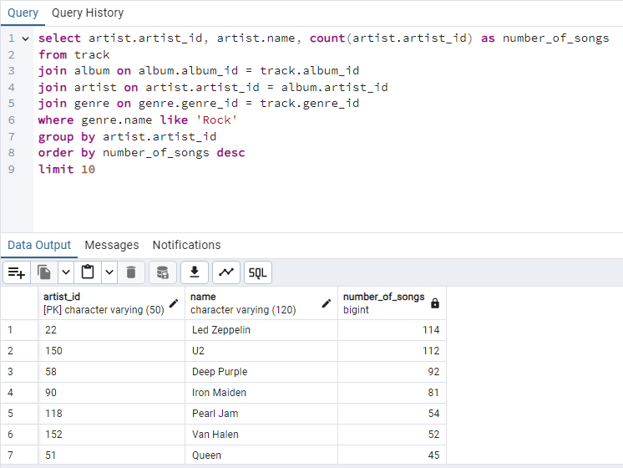
- Return all the track names that have a song length longer than the average song length. Return the Name and Milliseconds for each track. Order by the song length with the longest songs listed first
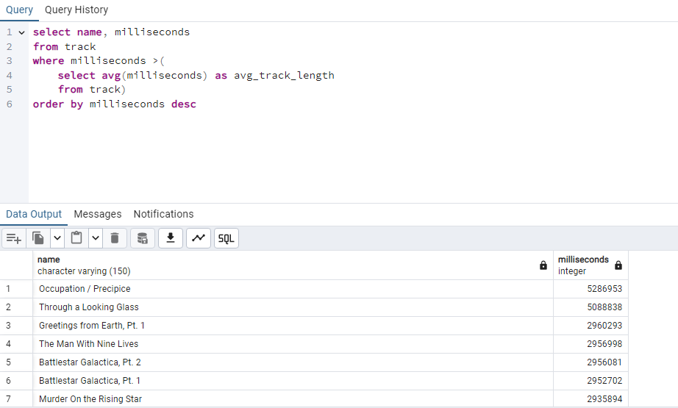
- Find how much amount spent by each customer on artists? Write a query to return customer name, artist name and total spent
Query :
WITH best_selling_artist AS (
SELECT artist.artist_id AS artist_id, artist.name AS artist_name, SUM(invoice_line.unit_price*invoice_line.quantity) AS total_sales
FROM invoice_line
JOIN track ON track.track_id = invoice_line.track_id
JOIN album ON album.album_id = track.album_id
JOIN artist ON artist.artist_id = album.artist_id
GROUP BY 1
ORDER BY 3 DESC
LIMIT 1
)
SELECT c.customer_id, c.first_name, c.last_name, bsa.artist_name, SUM(il.unit_price*il.quantity) AS amount_spent
FROM invoice i
JOIN customer c ON c.customer_id = i.customer_id
JOIN invoice_line il ON il.invoice_id = i.invoice_id
JOIN track t ON t.track_id = il.track_id
JOIN album alb ON alb.album_id = t.album_id
JOIN best_selling_artist bsa ON bsa.artist_id = alb.artist_id
GROUP BY 1,2,3,4
ORDER BY 5 DESC;

Output :
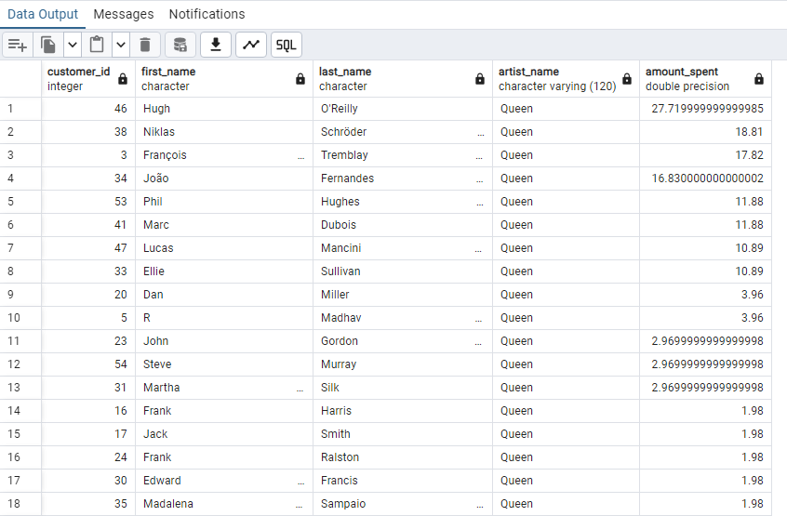
- We want to find out the most popular music Genre for each country. We determine the most popular genre as the genre with the highest amount of purchases. Write a query that returns each country along with the top Genre. For countries where the maximum number of purchases is shared return all Genres
Query :
WITH popular_genre AS
(
SELECT COUNT(invoice_line.quantity) AS purchases, customer.country, genre.name, genre.genre_id,
ROW_NUMBER() OVER(PARTITION BY customer.country ORDER BY COUNT(invoice_line.quantity) DESC) AS RowNo
FROM invoice_line
JOIN invoice ON invoice.invoice_id = invoice_line.invoice_id
JOIN customer ON customer.customer_id = invoice.customer_id
JOIN track ON track.track_id = invoice_line.track_id
JOIN genre ON genre.genre_id = track.genre_id
GROUP BY 2,3,4
ORDER BY 2 ASC, 1 DESC
)
SELECT * FROM popular_genre WHERE RowNo <= 1

Output :

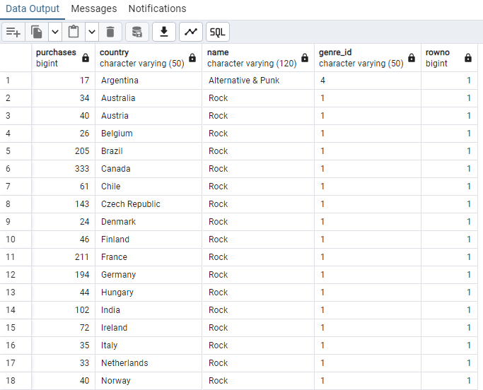

- Write a query that determines the customer that has spent the most on music for each country. Write a query that returns the country along with the top customer and how much they spent. For countries where the top amount spent is shared, provide all customers who spent this amount
